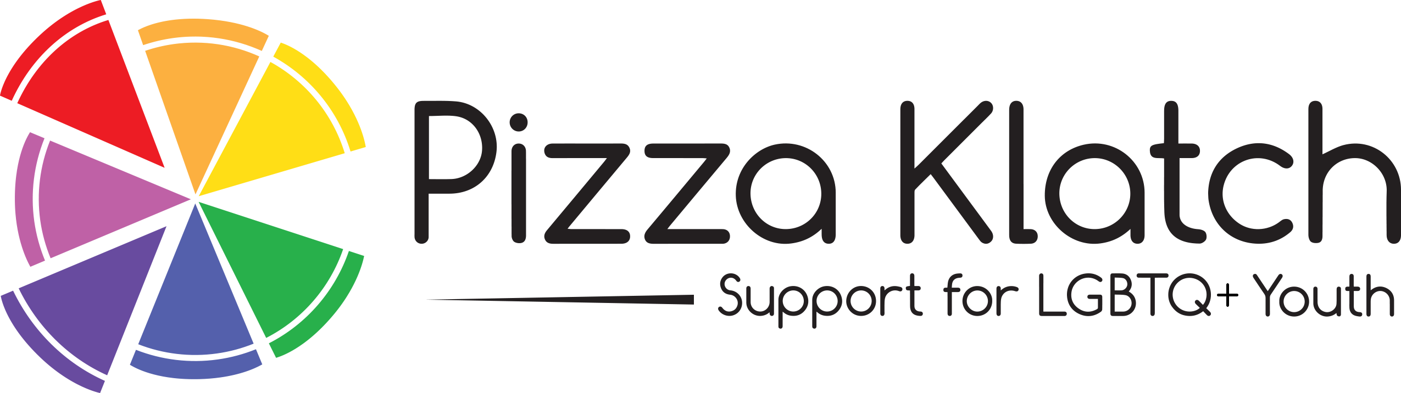

Donor information Please fill out ALL spaces
Donor Name (Business or Individual) (as it should appear in the event program on the auction donation page)

Contact Person (if business) | Contact Phone Number
Address | City State ZIP
Email | Donor’s Signature | Date
Auction Item Information
Donation Deadline: November 15 1212vember 30, 2016
Item or Service being donated: | Estimated Market Value? $_________________  Minimum Bid (if desired)? $___________
Detailed Item Description (quantity, size, color, related promotional links, other relevant information):

TITLE you would like for your item on the online donation page?

Restrictions (any limitations, special conditions, additional costs, expiration, minimum it can sell for, etc)

Mark Appropriate Boxes  ______ Delivery by Donor _____ To be picked by auction representative  ______ Donor provides gift certificate _____ Auction committee creates certificate  ______ Donor provides promo material  Pick up/delivery date: _______________________ |  | Certificate Redemption Deadline  2/28/20 if not otherwise indicated)  Other: ________________________
For official use only
Procured/Contacted By | Contact’s Phone | Put in SAP and Item # Assigned

Please complete and return this form (as well as any gift certificates, vouchers, etc) to:

Ely Cunningham, Auction Chair via email at: ely33cun@gmail.com

Questions? call Ely at (253) 414-8316 or Lynn at (360) 556-2506

Auction will be online beginning Jan. 19 and will end at the Slice of a Good Life Pizza Klatch Gayla on Saturday, Feb. 2, 2019
Pizza Klatch is a 501(c)(3) non-profit organization. Your donation may be tax deductible. Fed.Tax ID #45-5534793

